Part 1

Write a Java program to accomplish each of the following tasks:
- Prompt the user of the program for a decimal number.
- Assign the number to a suitable variable.
- The output of program should match the following…..

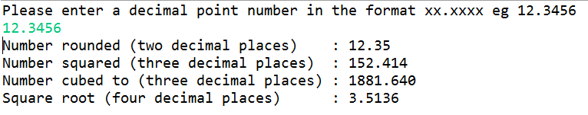

Note : You will need to perform several maths operations to produce the required output. But there are in built Java functions that would allow you to do some of these (Hint java.lang.Math)
Also always try to write efficient code... do you need to create a new variable to store the result of each operation before outputting to screen?

Part 2 – IF.. ELSE Statements (Masters grading)
Write a Java program to accomplish each of the following tasks:
- Prompt the user of the program for a final mark for a Masters student (between 0 – 100).
- Assign the number entered to a suitable variable.
- Using only IF .. ELSE IF statements output the Masters Classification corresponding to number entered by the user.
0-49 Fail
50-59 Pass
60-69 Merit
70-100 Distinction

Note : if the user enters a number outside the range output a suitable error message
- Test your program.

Output examples

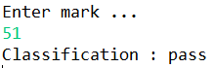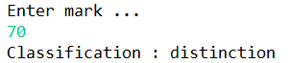

Part 3 – Selection statements
Voting calculator - Write a Java statement to accomplish each of the following tasks:
- Prompt the user for their country from the following options…
1. Austria 2. Singapore 3. UK.
- Then prompt the user for their age.
- Using appropriate selection statements, IF.. ELSE and SWITCH, calculate if the user is old enough to vote in their chosen country then output :
“You are old enough to vote in <country>”
Otherwise output :
“You are not old enough to vote in <country>.
You can vote in <country age – user age> year(s)”

Notes :
The voting ages in the countries are:

Austria 16
Singapore 21
UK 18

Declare these values as constants in this program.

Example outputs…

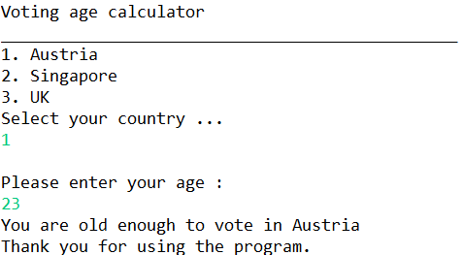

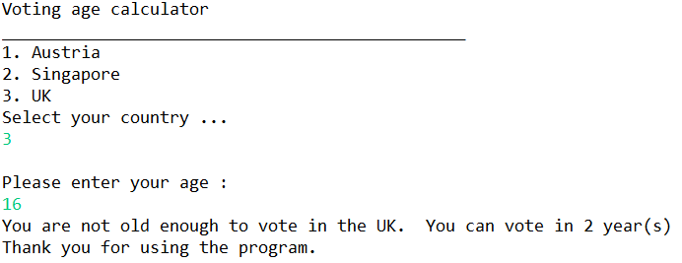

- Test your program. You should test ALL possible options.

- Program update – the voting age in the UK is being changed to 20. Update your program and test.

Part 4 – More Selection statements

- Prompt the user for his/her age. Then check if the user is over 17. If so then prompt the user for a name. Then output the user’s inputted name and age. Otherwise if not over 17 then output “too young to continue” (i.e. do not prompt for name). In addition ensure that the user does not enter a negative number or 0 for age. (if so exit the program gracefully with “sorry don’t recognise your input”.
- Use the an if … else statement: to check a user input value into a voting system. The user should be presented with two options ‘con’ and ‘lab’. (Representing Conservative and Labour. If the entry is con then output “Voting registered for Conservative” and “Voting registered for Labour” upon ‘lab’ entry. Ignore the case that the user enters these values in.
(Your program should use the conditional operator to help convert the input value (con or lab) to Labour or Conservative respectively.
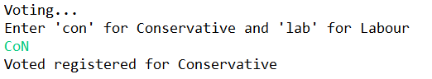

Also add some validation to ensure the user cannot register a vote if they type any other entry(see below)

